
Name = Muhammad Daniyal
Registration no = 24371
Submitted to : Mam Faryal
Date : 18/05/2026

Software Construction and Development CA

Lab 9

Task 1:
Write a program that:

- Takes a student name and marks as input
- Saves the data into a file named student.txt

Input.output:

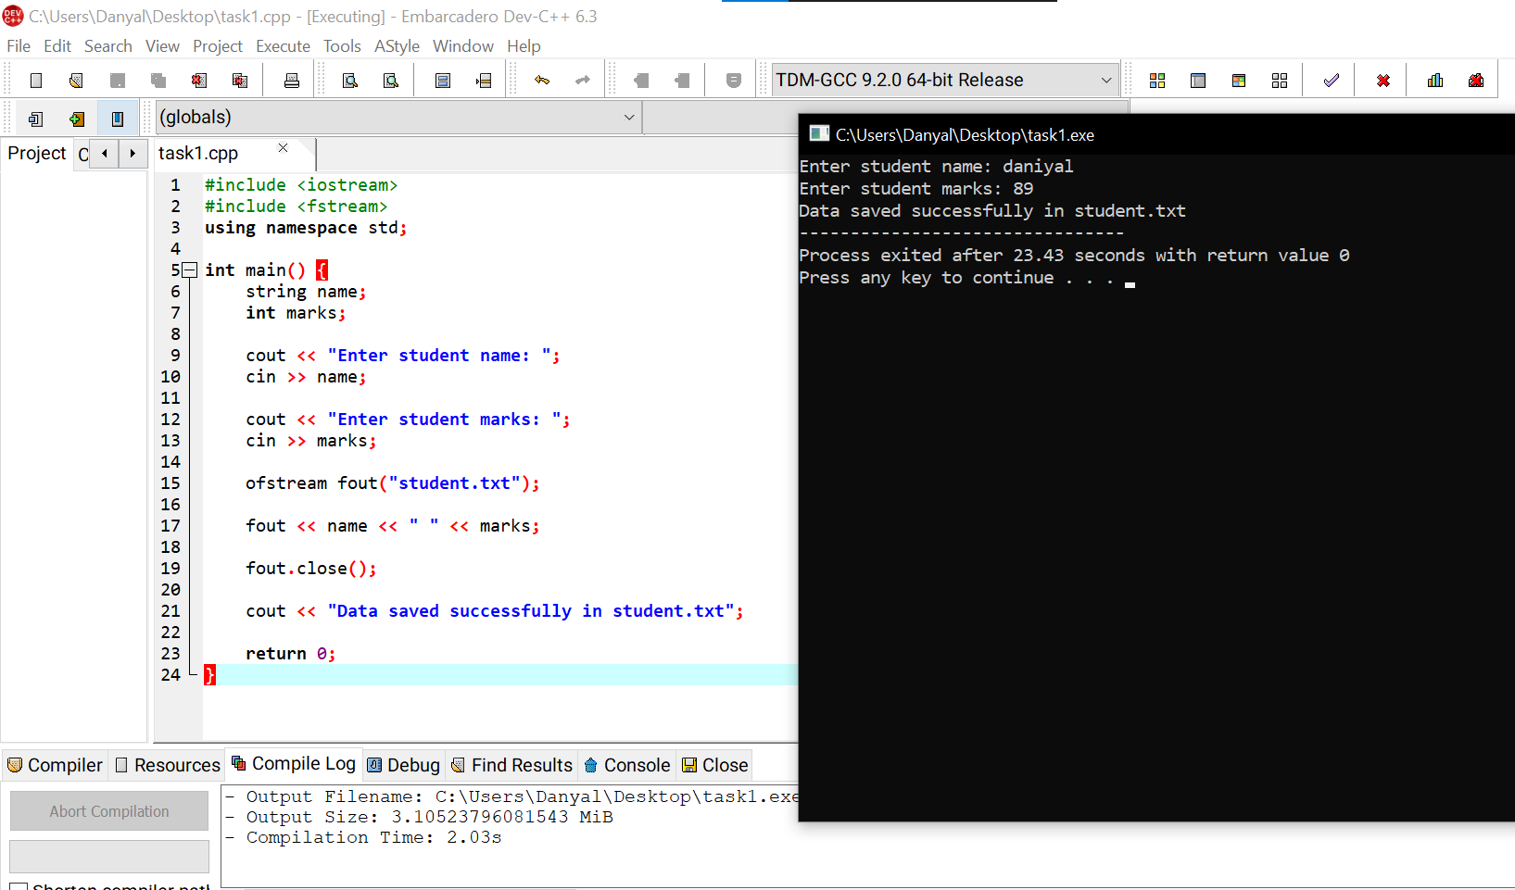
- Task 2:
Write a program to:
- Read data from student.txt
- Display the contents on the screen.

Input/output:
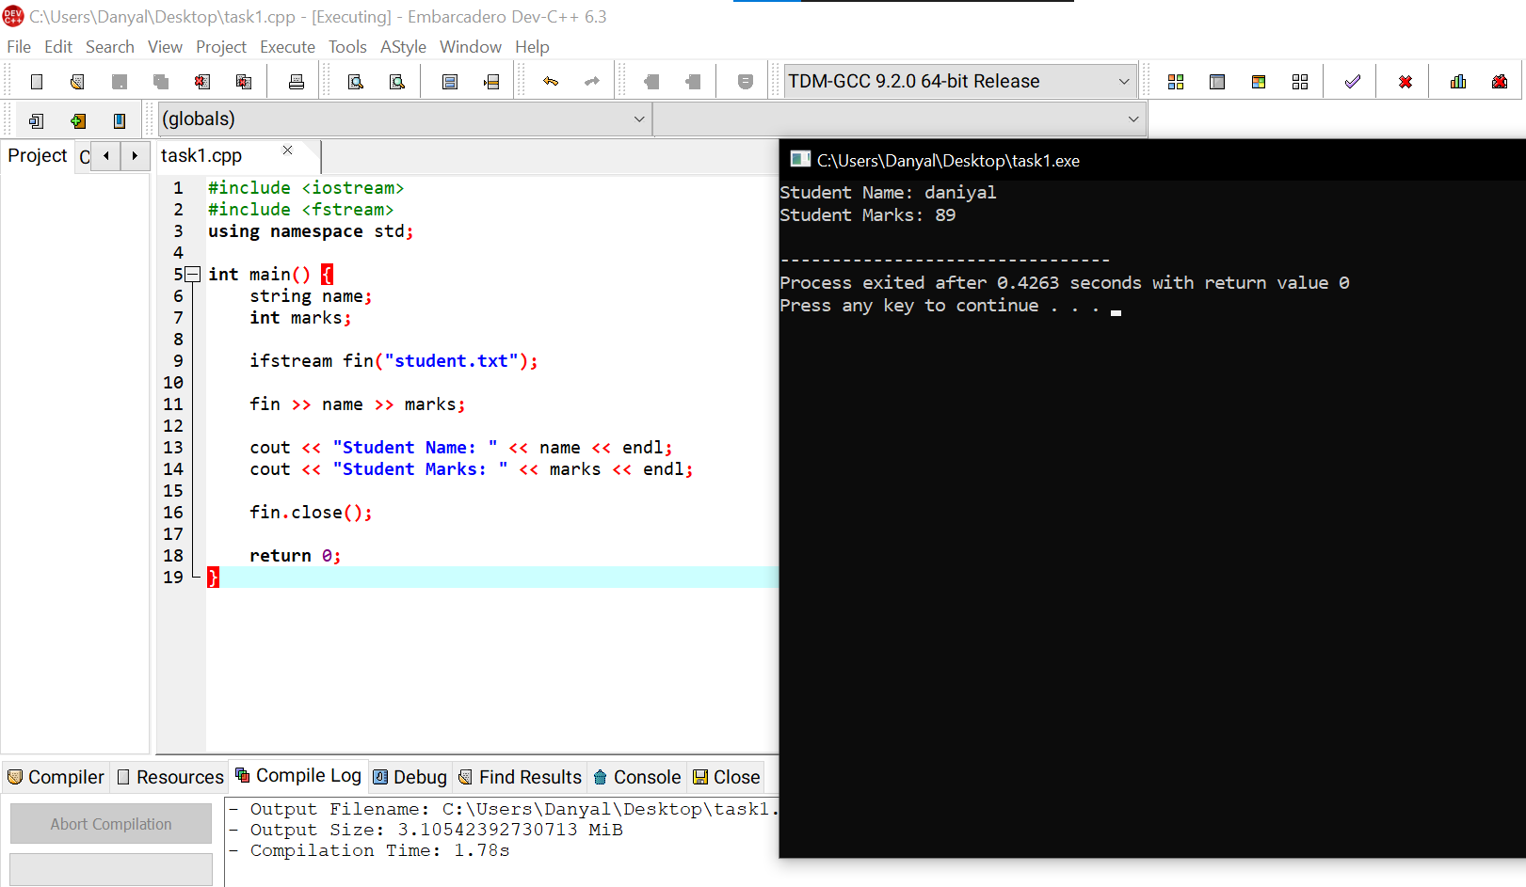

Task 3:
Write a program that:
- Stores 5 numbers in a file
Reads them back and calculates their sum.

Input/output:
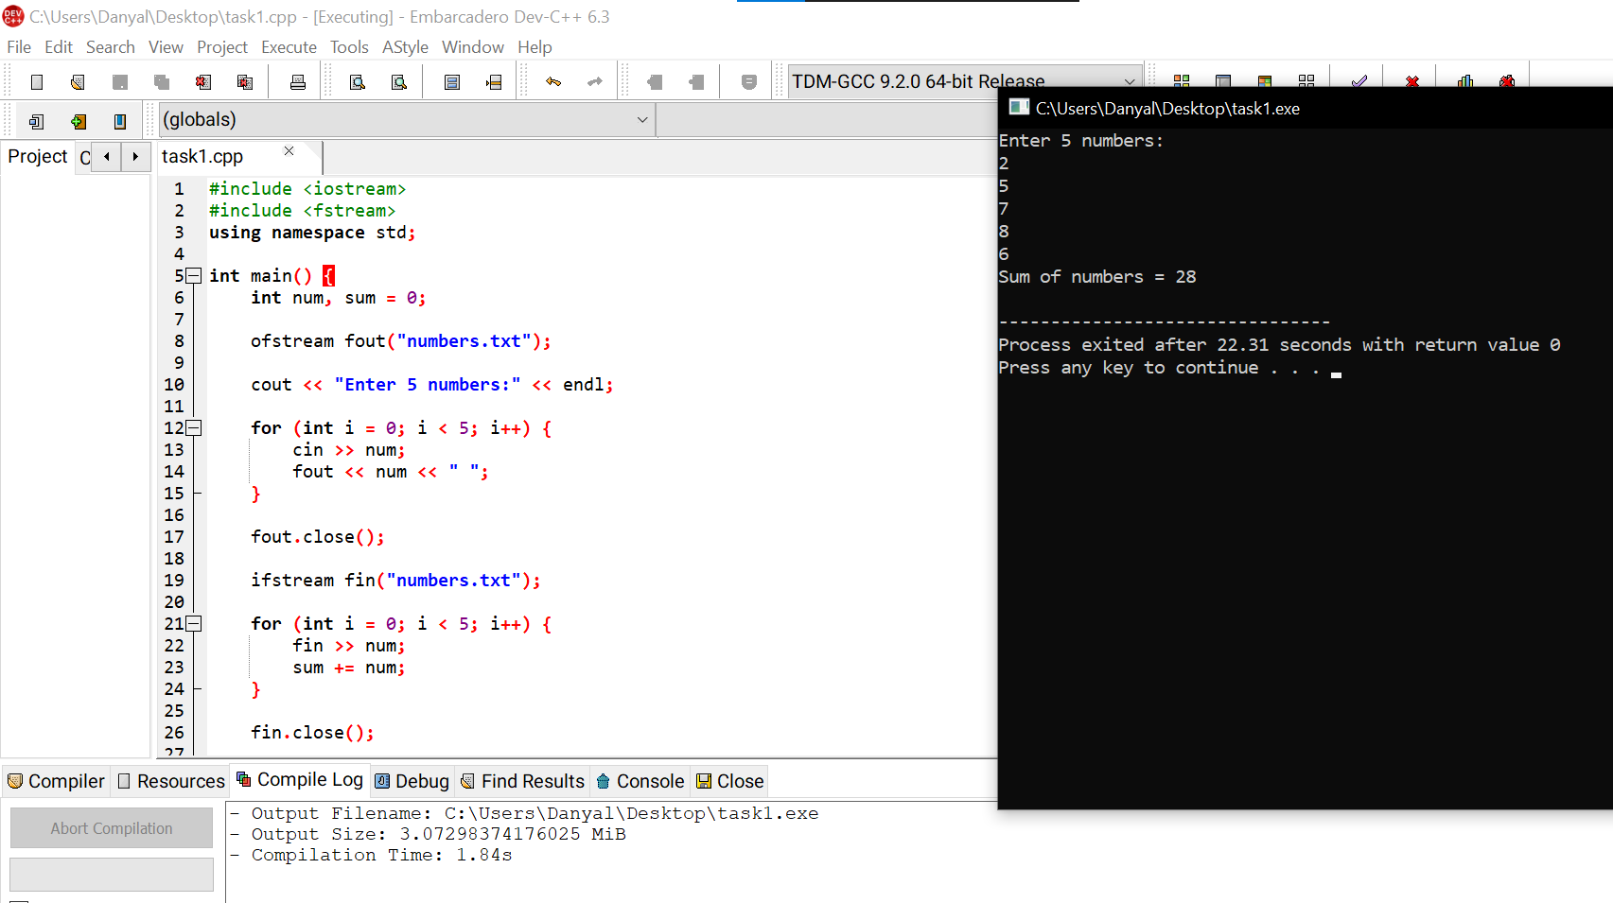

- Task 4:
Create a program to:
- Append a new record (name and age) to an existing file without deleting previous data.
Input/output:
